SonarQube Configuration

SonarQube is used for Code Quality Analysis and provides the capability to not only show the health of an application but also to highlight issues newly introduced. With a Quality Gate in place, you can fix the leak and therefore improve code quality systematically.

Configuring SonarLint 3.3 Plugin in Eclipse:-

Step 1:
Check the Java configured on your local pc.
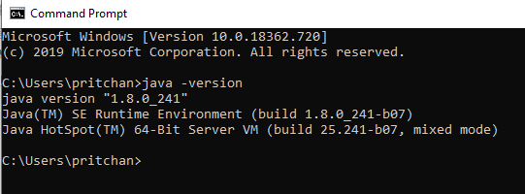

Step 2: Download the Eclipse SonarLint plugin
Eclipse -> help -> Eclipse MarketPlace -> Type sonarLint -> click install (Restart eclipse after it has been installed successfully).

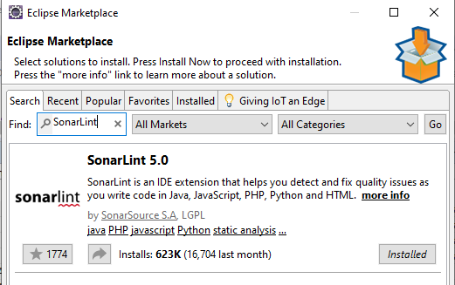
Step 3:
To run sonarLint automatically, enable the checkbox under project properties. It helps developers to highlight errors and bugs while writing code.
Project -> Properties -> SonarLint
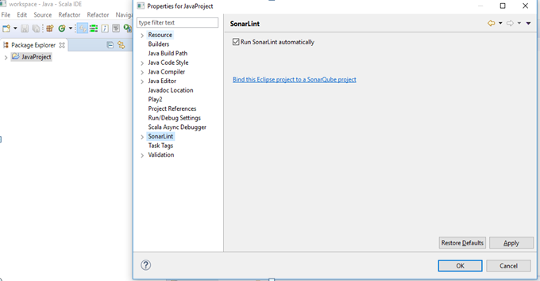

Step 4:
Select the SonarLint console to view the sonarLint log.

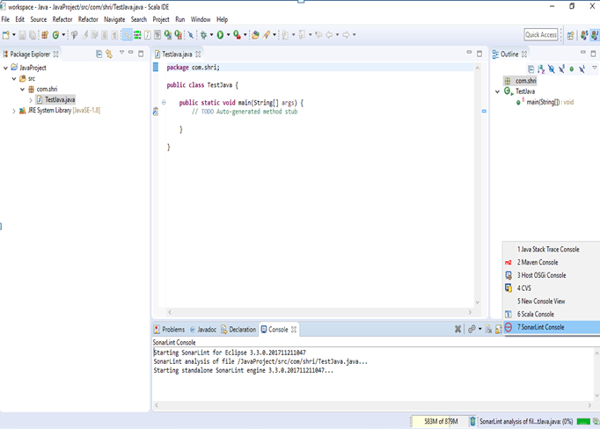
Step 5:
How do you use the sonarLint report?
- Every Save, sonarLint Start analyzes the code and the report is shown in the SonarLint Report tab.
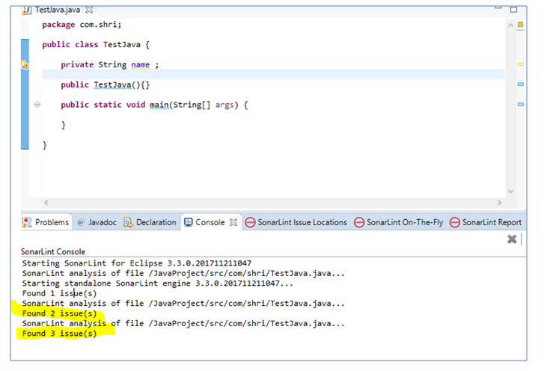
- To view issues, click the SonarLint On-The-Fly tab.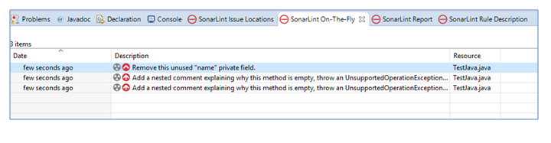
- To view the Rule Description:
  - Right-click and select Rule description.
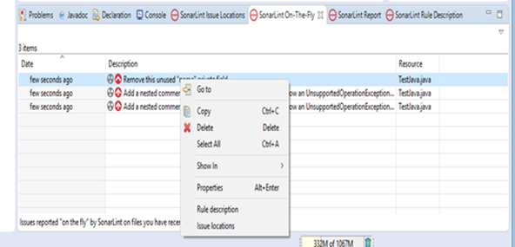
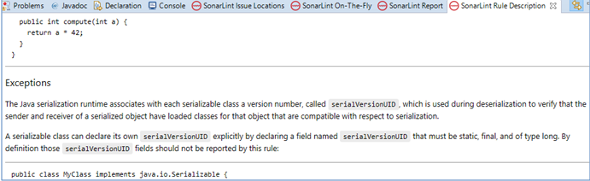

Steps to Configure an Eclipse Project in a SonarQube Centralized/Local Server

Step 1:
Login to the SonarQube web server with a default link:
  - http://whf00bes.in.oracle.com:9000/dashboard
  - Default credentials : admin/admin
  - 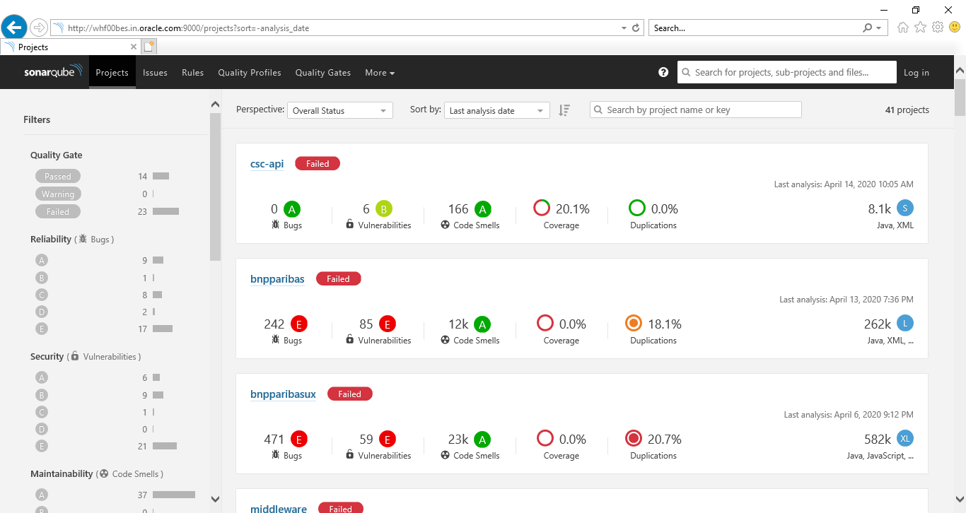

Step 2:
Bind an Eclipse project with a SonarQube project by clicking:
Project ->SonarLint->Bind to SonarQube Project
• Connect to the SonarQube Local server:
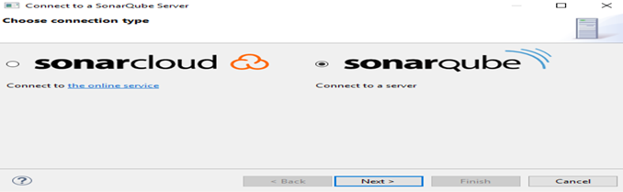
- Pass the SonarQube server URL and click Next.
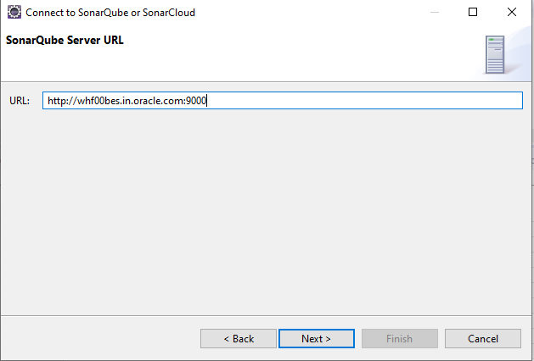

- Click “Next”.
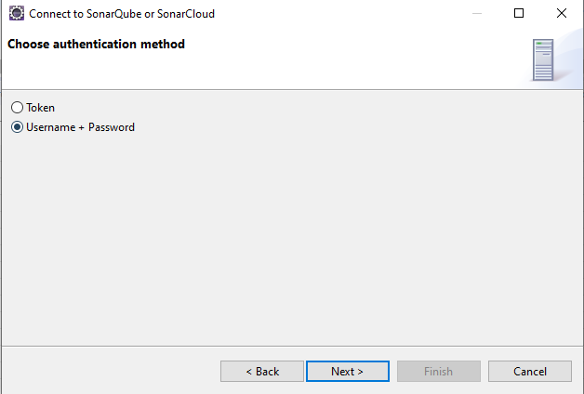
- There are two methods to connect to the server. I have chosen to use my username/password and passed default credentials (admin/admin) to pass the test connection.
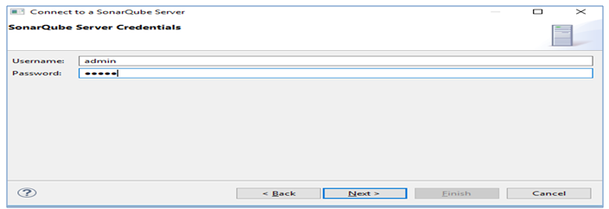

- Choose the Connection Name.
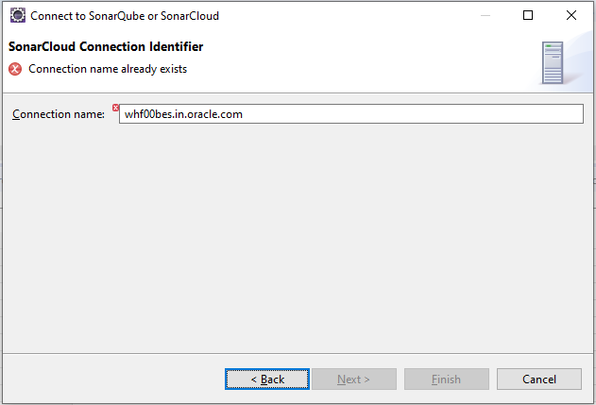
- Finish
- Run the SonarQube analyzer by clicking the Analyze button.
